**Hello World in Spring Boot Application as API**

Hey folks! All we know that what is hello world program. It’s a very simple example to go ahead in any language, so we are here to express interest in this course so that you will be in touch from base to expertise level in development with spring boot microservices.

Download link is <https://github.com/HeeraBabu007/MicroservicesCourse/archive/master.zip>

You can download the application here, in this download folder you will see some of the images that will help you to understand the project.

Now, we are going to see the hello world example in spring boot…….

Lets follow the simple steps to create spring boot application in java……

1. go the <https://start.spring.io/>

2. fill the group and artifect id and add the dependencies

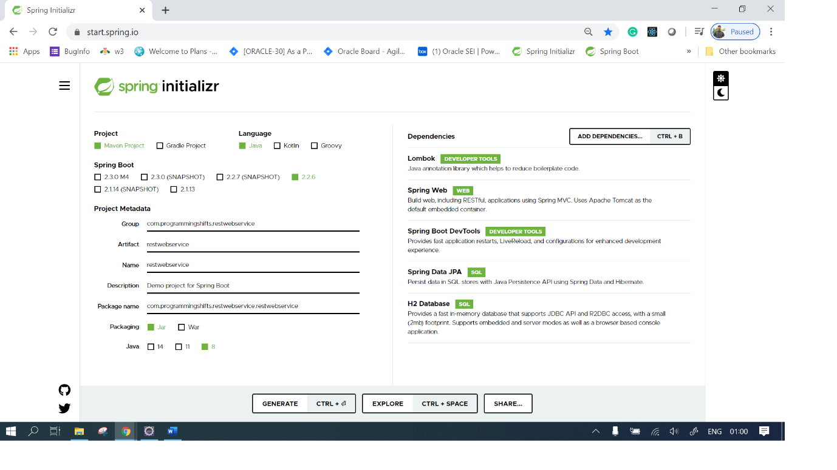

3. download the zip

4. unzip in the eclipse workspace and open it while you are using internet, so that maven can download the jar from maven repository.

After downloading all the jar your project will look like as below

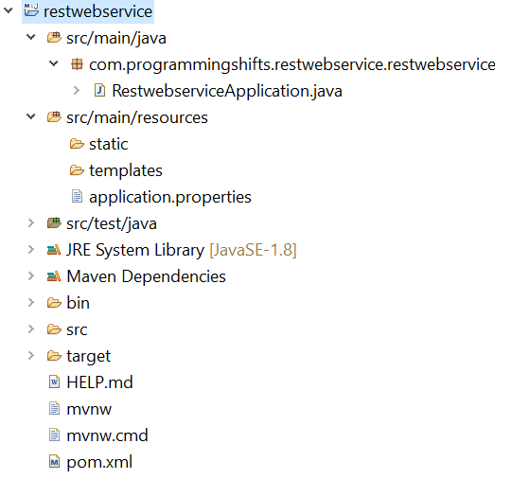

Now use the following steps to run this project.

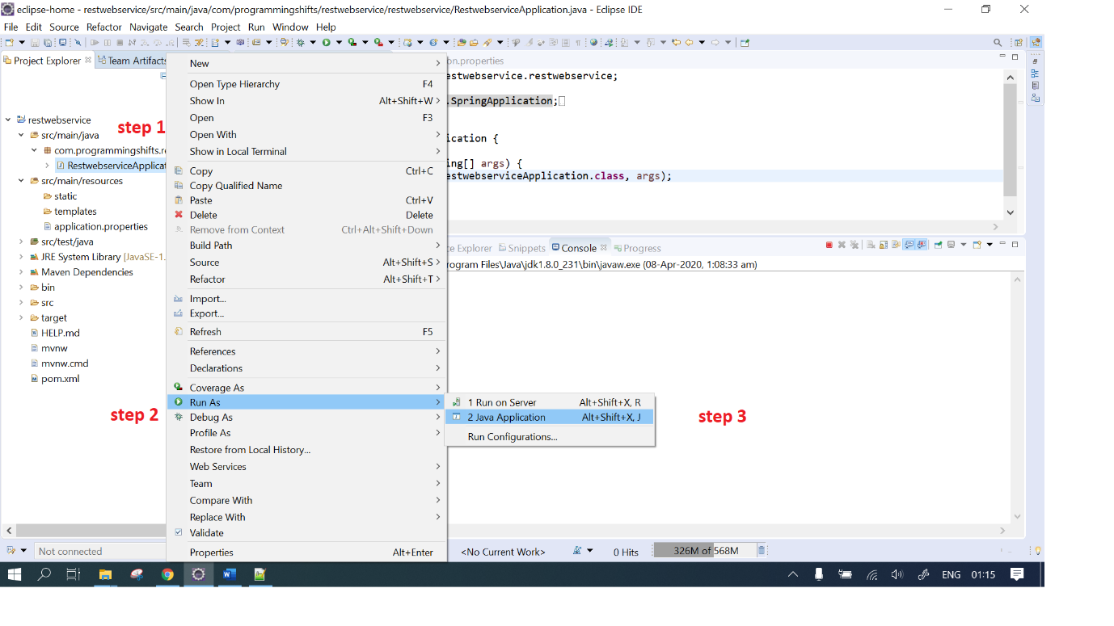

Now, follow the steps and see the output

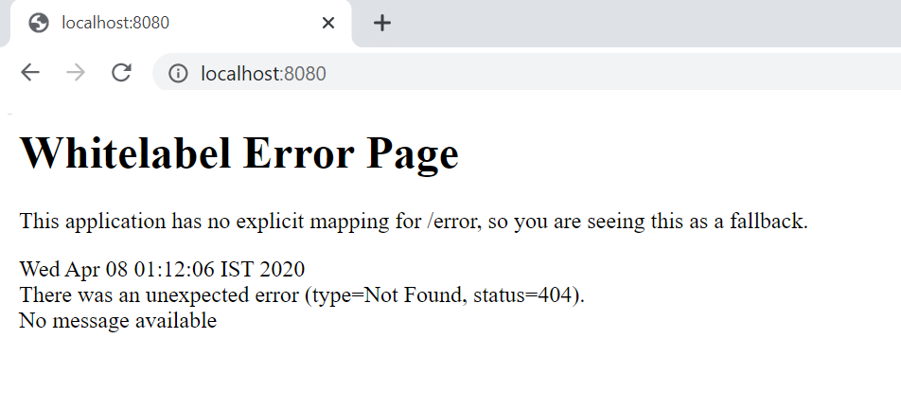

There is no any error, it looks like this is error, but this is default error page from spring boot that handles the exception.

To complete the example of hello world we need an controller to display the hello world.

**package** com.programmingshifts.restwebservice.restwebservice.controller;

**import** org.springframework.web.bind.annotation.GetMapping;

**import** org.springframework.web.bind.annotation.RestController;

@RestController

**public** **class** MainController {

@GetMapping("/greetings")

**public** String GreetingMethod() {

**return** "Hello World";

}

}

Now the output will be as below:

